15.9: a) 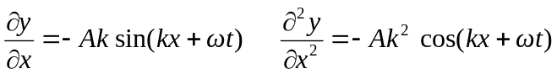

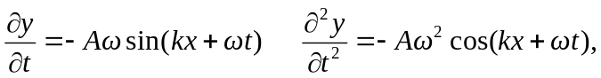

and so 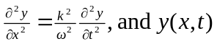 is a solution of Eq. (15.12) with 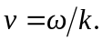

b) 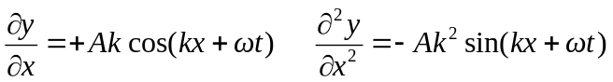

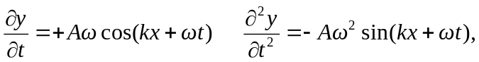

and so is a solution of Eq. (15.12) with 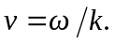 c) Both waves are moving in the -direction, as explained in the discussion preceding Eq. (15.8). d) Taking derivatives yields

